Superior University Gold Campus
Lab Task 6
Artificial Intelligence Lab
Name: Tasawar Hussain
Roll no: SU92-BSSEM-F24-073

1> Objective :
The objective of this task is to compare basic tokenization techniques specifically whitespace splitting and Unicode word like regular expressions across five diverse input cases punctuation contractions email addresses course codes and empty strings Furthermore, it evaluates the execution behavior and response strategy of a retrieval based FAQ chatbot
2> Tokenization Method Comparison & Analysis :
Input Sample | Whitespace Tokens (text.split()) | Word-Like Regex Tokens (re.findall) | Key Difference & Observation
AI, search! | ['AI,', 'search!'] (Count: 2) | ['AI', 'search'] (Count: 2) | Whitespace retains punctuation (, and !), while Regex strips all punctuation.
I can't log in. | ['I', "can't", 'log', 'in.'] (Count: 4) | ['I', 'can', 't', 'log', 'in'] (Count: 5) | Contraction "can't" stays intact in whitespace, but splits into ['can', 't'] in Regex.
help@example.com | ['help@example.com'] (Count: 1) | ['help', 'example', 'com'] (Count: 3) | Email stays as a single unit in whitespace, but gets fragmented into three words in Regex.
CS4944 version 2.1 | ['CS4944', 'version', '2.1'] (Count: 3) | ['CS4944', 'version', '2', '1'] (Count: 4) | Version number "2.1" splits into '2' and '1' in Regex, losing decimal context.
"" (Empty String) | [] (Count: 0) | [] (Count: 0) | Both methods handle empty strings gracefully by returning empty lists.
Key Differences & Normalization Risks:
- Punctuation & Contraction Handling: Whitespace splitting attaches punctuation directly to tokens (e.g., "search!"), which degrades keyword matching. Regex removes punctuation but damages contractions (splitting "can't" into "can" and "t").
- Identifier Fragmentation Risk: Blind regex tokenization breaks special patterns like email addresses (help@example.com) and decimal identifiers (2.1) into separate tokens, causing semantic distortion during information retrieval.
3> Terminal Output Screenshot :
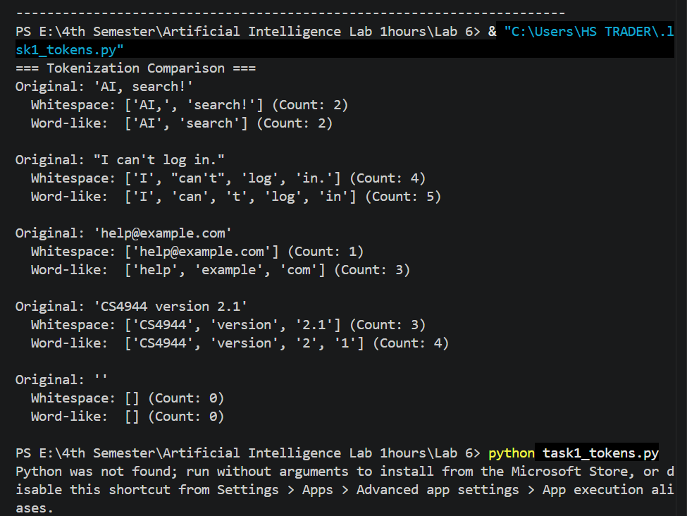
4> FAQ Chatbot Evaluation & Confirmation Logic :
- Exact Answer Logic: When a user query matches a stored canonical question exactly, the chatbot immediately returns the authoritative answer along with its source file tag.
- Confirmation / Fallback Logic: For non-exact or paraphrased queries, the chatbot asks for confirmation and presents candidate suggestions rather than asserting a potentially wrong answer. This conservative approach prevents the retrieval pipeline from outputting incorrect or hallucinated policy information.

